**HOMEWORK WRITE UP**  
The program “generate_solution” started off with the base file given in class. I then realized that all I had to do was edit the code inside of the second try catch. The first thing that I did was change the first if statement to this “if(args.length != 4)” so that the program would incorporate the new elements added to the program. The next thing I did was add an else at the end of that if statement so that the program would not run the rest of the program. I know that there is “System.exit(1)”, but this was just an extra measure. The next thing I did was assign variables for the next few given values and print the specified messages to the screen with the given format. 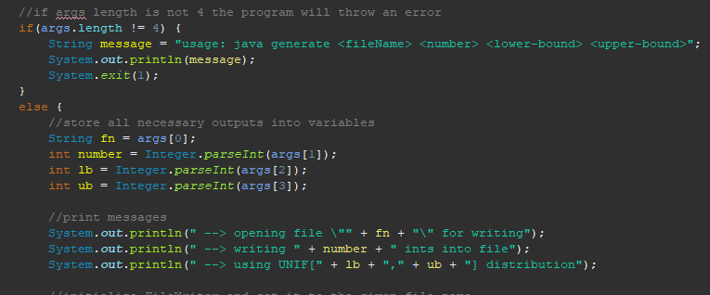

After that was all finished I went to the second try catch to try and solve the problem. With using a little help from ChatGPT I was able to figure out how the “Random” and “BufferedWriter” variable works and initialized it inside of this second try catch. I then created an Array that was set to the second number given. I then indexed this array by its length so that there would be no errors. Inside of the for loop I assigned the values of the array by using the random variable previously created. This assignment looks for the next random int given a specified range. After the value inside of the array is assigned, I then write that value into the file, shown here.

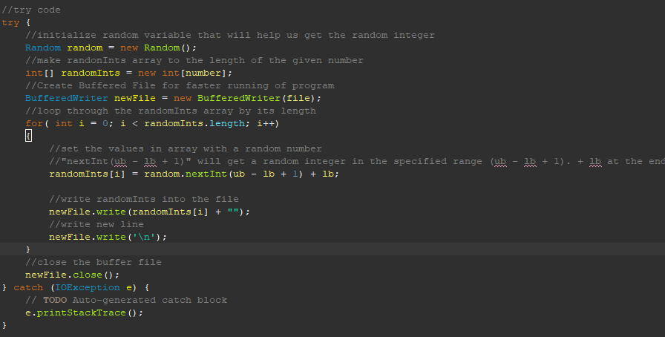

After I completed that I was finished with the project. The only thing left to do was figure out how to get the amount of time the program took. I did this by two variables, startTime and endTime. The start time is declared at the beginning of the program with the current time in milliseconds. After the code is completed, I get the current time in milliseconds at the end of the program. After that I calculate the timeElapsed and then convert that into seconds which is then printed to the user. ChatGPT was able to help me with the System.currentTimeMillis() function, but I understand how this code works. Although it may not look exactly like yours, I think it looks better.

**HOMEWORK SCREENSHOTS**

